WEEK 13
Week Ending: 28-11-2025 |  |  | DAY: | Subject: COMPUTING
Duration: 50mins |  |  |  | Strand: Computational Thinking
Class: B7 |  |  | Class Size: | Sub Strand: Algorithm
Content Standard:  B7.4.1.1. Show an understanding of the concept of programming |  | Indicator:  B7.4.2.1.1  Understand the use of sequence, selection and iteration in writing a programme. |  |  |  |  | Lesson:  1 of 1
Performance Indicator:  Learners can demonstrate the use of constants and variables used in programming |  |  |  |  | Core Competencies:  Communication and Collaboration, Critical Thinking and Problem solving
References: Computing Curriculum Pg. 21
Keywords:
Phase/Duration | Learners Activities |  |  |  |  | Resources
PHASE 1: STARTER | Write numbers (1-10) in an orderly arrangement to represent sequence.  Have learners observe the pattern and talk about it.  Task learners to write thier itinerary for the day in a logical order to depict sequence.  Share performance indicators and introduce the lesson.
PHASE 2: NEW LEARNING | Brainstorm learners for the meaning of sequence, selection and iteration in writing a programme  Sequence is the order in which the statements in programing are executed one after another. The sequence of a program is extremely important as carrying out instructions in the wrong order leads to a program performing incorrectly.  Show pictures to learners to see a practical example of how a computer boots.  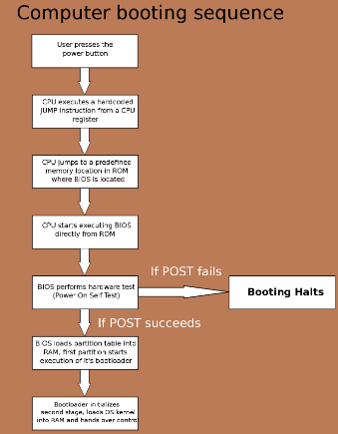  Explain sequencing as the means through which the computer runs a code in order, one line at a time from the top to the bottom of a program. It starts at line 1, then executes line 2, then line 3 and so on until it reaches the last line of the program.  Present a case study that has more than one option to choose from and still achieve the same outcome with any option chosen. For example, tea with or without sugar options can still meet a beverage outcome (selection).  Develop a solution to a problem which uses iteration to control the flow of the programme (iteration).  Guide la to describe the meanings of the term’s algorithm, decomposition and abstraction.  Demonstrate practically by using Programs such as lightbot for practical lessons.  Assessment:  Present a case study where there is more than one option to choose from, and yet any option selected leads to the same outcome |  |  |  |  | Pictures and videos
PHASE 3: REFLECTION | Use peer discussion and effective questioning to find out from learners what they have learnt during the lesson.  Take feedback from learners and summarize the lesson.

